RAJALAKSHMI ENGINEERING COLLEGE

**RAJALAKSHMI NAGAR, THANDALAM – 602 105**



|  |
| --- |
| **CS23A34**  **USER INTERFACE AND DESIGN LAB** |
| **Laboratory Observation NoteBook** |

**Name :** SREYASKARI M

**Year/Branch/Section :** II/CSE/D **Register No. :** 230701335

**Semester :** IV

**Academic Year:** 2024-25

**Ex. No. : 5a**

**Register No. : 230701335 Name : Sreyaskari M**

**Simulate the lifecycle stages for UI design using the RAD model and develop a small interactive interface using**

**Axure RP**

**AIM:**

The aim is to demonstrate the lifecycle stages of UI design via the RAD model and develop a small interactive interface employing Axure RP.

**PROCEDURE:**

Tool Link: https://[www.axure.com/](http://www.axure.com/)

Simulating the Lifecycle Stages for UI Design Using the RAD Model

RAD Model (Rapid Application Development): The RAD model emphasizes quick development and iteration. It consists of the following phases:

1. Requirements Planning:
   * Gather initial requirements and identify key features of the UI.
   * Engage stakeholders to understand their needs and expectations.
2. User Design:
   * Create initial prototypes and wireframes.
   * Conduct user feedback sessions to refine the designs.
   * Use tools like Axure RP to develop interactive prototypes.
3. Construction:
   * Develop the actual UI based on the refined designs.
   * Perform iterative testing and feedback cycles.
4. Cutover:
   * Deploy the final UI.
   * Conduct user training and support.

Axure RP Interactive Interface Development Phase 1: Requirements Planning

1. Identify Key Features:
   * Navigation (Home, Product Categories, Product Details, Cart, Checkout,

Order Confirmation, Order History)

* + User actions (Browsing, Searching, Adding to Cart, Checkout, Tracking Orders)

1. Create a Requirements Document:
   * List all features and functionalities.
   * Document user stories and use cases.

Phase 2: User Design

1. Install and Launch Axure RP:
   * Download and install Axure RP from Axure&'s official website.
   * Launch the application.
2. Create a New Project:
   * Go to File -&gt; New to create a new project.
   * Name the project (e.g., "Shopping App Interface").
3. Create Wireframes:
   * Use the widget library to drag and drop elements onto the canvas.
   * Design wireframes for each screen:

* Home Page
* Product Categories
* Product Listings
* Product Details
* Cart
* Checkout
* Order Confirmation
* Order History

1. Add Interactions:
   * Select an element (e.g., button) and go to the Properties panel.
   * Click on Interactions and choose an interaction (e.g., OnClick).
   * Define the action (e.g., navigate to another screen).
2. Create Masters:
   * Create reusable components (e.g., headers, footers) using Masters.
   * Drag and drop masters onto the wireframes.
3. Add Annotations:
   * Add notes to describe each element's purpose and functionality.
   * Use the Notes panel to add detailed annotations.

Phase 3: Construction

1. Develop Interactive Prototypes:
   * Convert wireframes into interactive prototypes by adding interactions and transitions.
   * Use dynamic panels to create interactive elements (e.g., carousels, pop - ups).
2. Test and Iterate:
   * Preview the prototype using the Preview button.
   * Gather feedback from users and stakeholders.
   * Make necessary adjustments based on feedback.

Phase 4: Cutover

1. Finalize and Export:
   * Finalize the design and interactions.
   * Export the prototype as an HTML file or share it via Axure Cloud.
2. User Training and Support:
   * Conduct training sessions to familiarize users with the new interface.
   * Provide documentation and support for any issues.

**OUTPUT:**

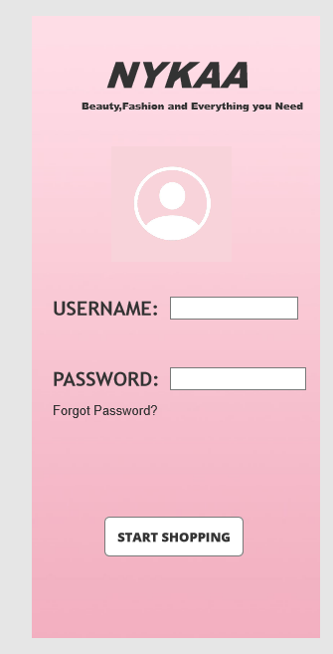

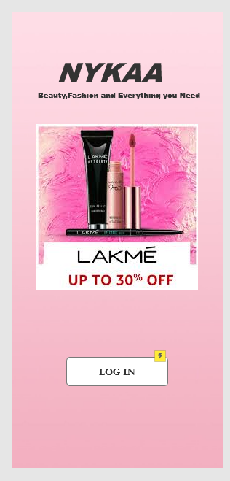

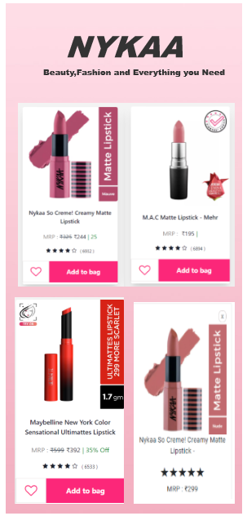

**RESULT:**

Hence, demonstration of the lifecycle stages of UI design via the RAD model and develop a small interactive interface employing Axure RP.